**1. Team Members and Distribution**

Heming Yu

Project Manager

(1) Be responsible for the overall situation of the whole project

(2) Coordinate the cooperation and communication among personnel

(3) Actively promote the steady progress of the project, complete the formulated plan on schedule

(4) Ensure that the project can achieve the expected effect in the end

+Jianqiao Chen

Knowledge Engineer

(1) His research direction is how to build a good knowledge map

(2) Fully analyze and utilize the collected data

(3) Reasonably match and build

(4) Establish a relatively complete and reasonable knowledge map

+ An Wang

Data Scientist

(1) Mainly responsible for sorting, classifying and storing the collected data

(2) Discuss the specific algorithm of data processing with domain expert and implement it with code

(3) Discuss with knowledge engineer how to build the knowledge map and implement it in code

(4) Ensure that the final data and code of the project can be completely implemented

**2 Refined Context**

**2.1 Domain of interest**

Recommendations for winner of League of Legends S13 World Championship

**2.2 Personas**

Audiences

**2.3 Scenarios**

For a game of S13 World Championship, the winner is recommended to audiences based on team comprehensive strength.

**3 Formalized Refined Purpose**

**3.1 Raw Competency Questions**

CQ1: Who is the winner of the two teams in League of Legends S13 World Championship competition?

CQ2: List all teams with its performance,historical records.

CQ3: List all players with their performance related to the team.

CQ4: List all competition with reward rate.

**3.2. Kernel Competency Questions**

CQ1: winner, teams, League of Legends S13 World Championship

CQ2: teams, performance, historical records

CQ3: players, performance, team

CQ4: competition,reward rate

**3.3. Analyzed Competency Questions**

CQ1:

Common: teams，competition

Core: winner

Contextual: League of Legends S13 World Championship

CQ2:

Common: teams

Core: performance,records

Contextual: historical

CQ3:

Common: players

Core: performance

Contextual: team

CQ4:

Common: competition

Core: reward rate

Contextual:

**3.4. Classified Competency Questions**

CQ1:

Common: Objects: Person, Winner

Core: Functions: teams

Contextual: Function: League of Legends S13 World Championship

CQ2:

Common: Objects: teams

Core: Functions: performance, records

Contextual: Function: historical

CQ3:

Common: Objects: Players

Core: Functions: performance

Contextual: Function: team

CQ4:

Common: Objects: competition

Core: Functions: rate

Contextual: Function: reward

**3.5. Attributed Competency Questions**

For (Team)：Team_ID, TeamName, NationalRank, TeamValue, AverageAge

For(Team_Performance):Team_ID,TeamName,TeamNationalRank,TeamKDA,TeamAverageKillPerGame,TeamAverageDeathPerGame,TeamDamagePerMinute,TeamMoneyPerMinute

For(Team_Historical_Record):Team_ID, TeamName, Event, EventValue, GameResult, GameResult_ID, Date

For(Player):Player_ID, PlayerName, PlayerPosition, PlayerAge,PlayerValue

For(Player_Performance):Player_ID,PlayerName,KDA,ParticipationRate,AverageKillPerGame,AverageDeathPerGame,DamagePerMinute,MoneyPerMinute ,Average AssistsPerGame

For(Reward_Rate):Team_ID, RedTeam,BlueTeam, RedWinRate, BlueWinRate

**4. Resource Selection**

**4.1. Knowledge Resources**

-Player and teamstatistics Dataset：

Score is an esports celebrity and anchor graphic, voice, and video information app. Focus on top players in the esports industry and get game information as soon as possible.

https://www.scoregg.com/

Play Plus esports is a cutting-edge esports platform that focuses on esports data, culture, business, and innovation. By mining the commercial value of events, teams, and players through data, and deriving a series of appealing brands.

https://www.wanplus.cn/

- Reward rate information Dataset：

As the largest anime video platform in China, Station B has more than 300 million monthly active users, many of whom are non core events or potential event users. During the S13 period, it provided reward rates for each team to provide a more unique viewing experience for the audience.

https://www.bilibili.com/online.html

**4.2. Data Resources**

- Alignment in format

Team-->Team_ID,TeamName, NationalRank, TeamValue, AverageAge

Team_Performance->Team_ID,TeamName,TeamNationalRank,TeamKDA,TeamAverageKillPerGame,TeamAverageDeathPerGame,TeamDamagePerMinute,TeamMoneyPerMinute

Player->Player_ID, PlayerName, PlayerPosition, PlayerAge,PlayerValue

Player_Performance->Player_ID,PlayerName,KDA,ParticipationRate,AverageKillPerGame,AverageDeathPerGame,DamagePerMinute,MoneyPerMinute ,AverageAssistsPerGame

Reward_Rate->Team_ID, RedTeam,BlueTeam, RedWinRate, BlueWinRate

- Sample and scale of the data retrieved

Team Dataset： 10

TeamPerformance Dataset：10

- Problems solved in retrieval

**5. EG file metadata**

Explaination of the ER

① Object

Person

Reward rate

② Function

Find the winner of competition.

③ Action

Teams will compete.

④ Property

- Object Property

Team

Reward rate

Team Performance

- Data Property

None

1. **ER**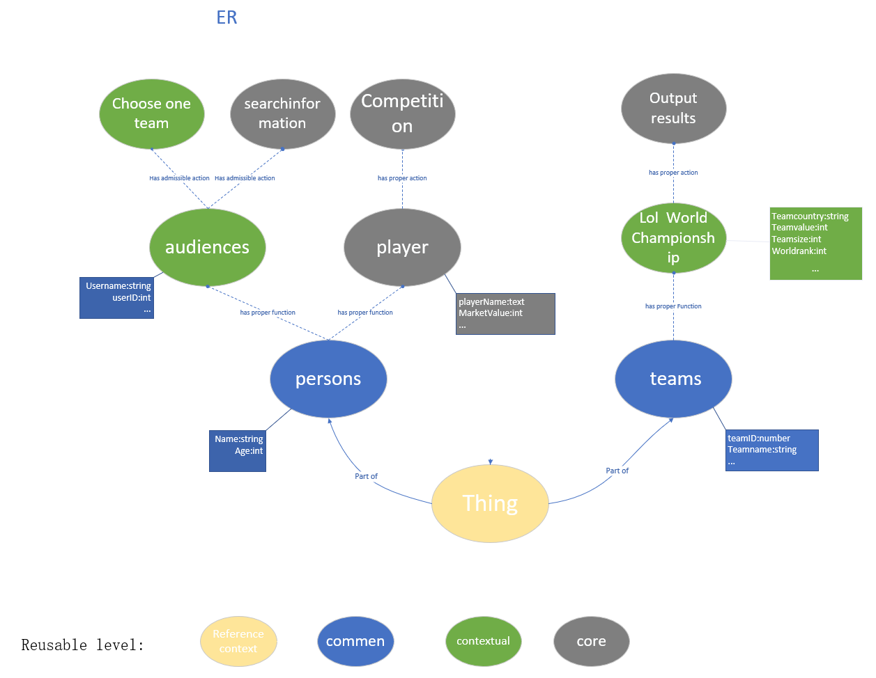

**7. FT-ETG-EG**

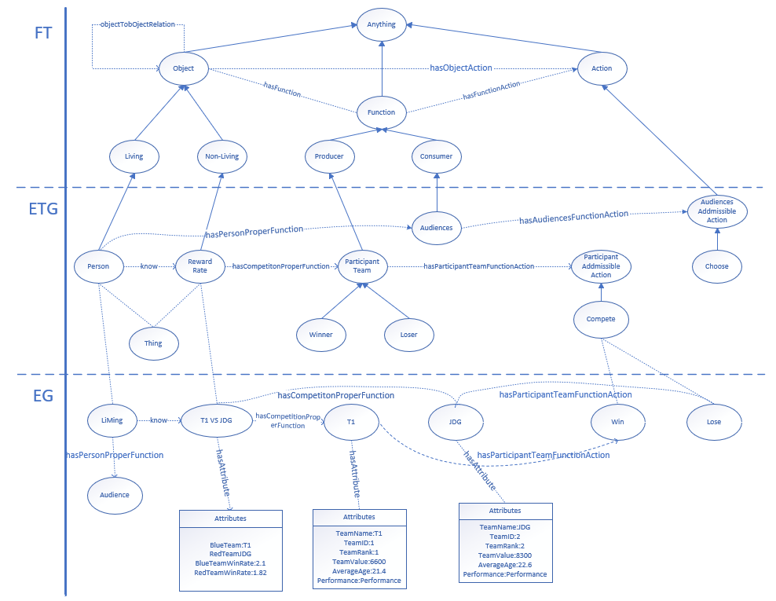

**8.** **Ontology**

